RESOLUTION NO.__________

RE: CERTIFICATE OF APPROPRIATENESS UNDER THE
PROVISIONS OF THE ACT OF THE PENNSYLVANIA
LEGISLATURE 1961, JUNE 13, P.L. 282 (53
SECTION 8004) AND BETHLEHEM ORDINANCE NO.
3952 AS AMENDED.

The applicant proposes to repaint the front of the building at 81 W. Broad St.

NOW, THEREFORE, BE IT RESOLVED by the Council of the City of Bethlehem that a Certificate of Appropriateness is hereby granted for the proposal.

Sponsored by: (s)

(s)

ADOPTED BY COUNCIL THIS DAY OF

(s)
President of Council

ATTEST:

(s)
City Clerk

HISTORICAL & ARCHITECTURAL REVIEW BOARD

The applicant proposes to repaint the front of the building at
81 W. Broad St.

APPLICATION #3:

Domenic Villani
930 Wafford Lane
Bethlehem, PA 18017

OWNER:

__________________________________________________________________________

The Board upon motion by Beth Starbuck and seconded by Derrick Clark adopted the proposal that City Council issue a Certificate of Appropriateness for the following:

- The masonry base and railing will be #SW2832 Colonial Revival Gray.

2. Main body of the façade will be #SW2835 Craftsman Brown. The frame detail
will be #SW2802 Rockwood Red.

3. All other trim to be #SW2807 Rockwood Medium Brown.

4. The motion was unanimously approved.

__________________________________________________________________________

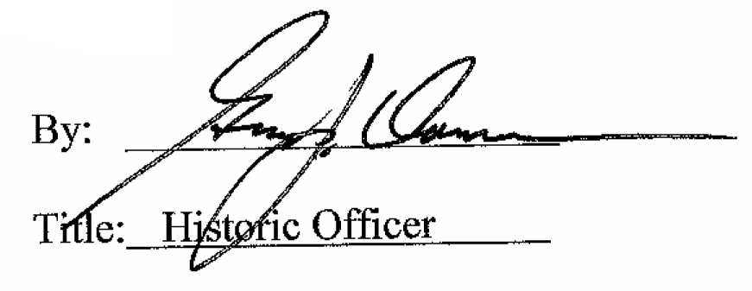

Date of Meeting: July 11, 2018

